Chapter 10, Problem 44.

Use superposition principle to obtain v_{x} in the circuit of Fig. 10.89. Let v_{s} = 50 sin2t V and i_{s} = 12 cos(6t + 10°) A.

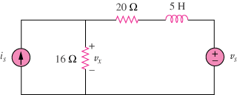

Figure 10.89
For Prob. 10.44.

